Homework #7

**Question** **1**

SELECT convert(varchar(10), OrderDate, 101) as 'Date of Order',

OrderID as 'OrderNumber',

concat(LastName, ', ', left(FirstName, 1), '.') as 'CustomerName',

'(' + substring(Phone, 1, 3) + ') ' +

substring(Phone, 4, 3) + '-' +

substring(Phone, 7, 4) as 'Phone Number'

FROM tblOrder

LEFT OUTER JOIN tblCustomer

ON tblOrder.CustomerID = tblCustomer.CustomerID

WHERE OrderDate BETWEEN ( '01/01/' + cast(year(getdate()) as varchar(4)))

AND ( '01/31/' + cast(year(getdate()) as varchar(4)))

ORDER BY OrderDate desc;

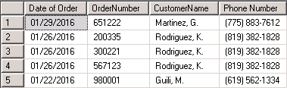



**Question 2**

SELECT convert(varchar(10), tblOrder.OrderDate, 101) as 'Date of Order',

concat(tblCustomer.LastName, ', ', left(tblCustomer.FirstName, 1), '.') as 'Customer Name',

tblOrder.OrderID as 'OrderNumber',

CASE

WHEN tblOrder.ShipAddress is not NULL

THEN tblOrder.ShipAddress

WHEN tblOrder.ShipAddress is NULL

THEN tblCustomer.Address

END ShipAddress,

CASE

WHEN tblOrder.ShipZip is not NULL

THEN tblOrder.ShipZip

WHEN tblOrder.ShipZip is NULL

THEN tblCustomer.Zip

END ShipCode,

CASE

WHEN tblOrder.ShipCountry is not NULL

THEN tblOrder.Shipcountry

WHEN (tblOrder.ShipCountry is NULL)

THEN 'Unknown'

END ShipCountry,

CASE

WHEN tblOrder.ShipCountry is NULL

THEN

'(' + substring(tblCustomer.Phone, 1, 3) + ') ' +

substring(tblCustomer.Phone, 4, 3) + '-' +

substring(tblCustomer.Phone, 7, 4)

WHEN tblOrder.ShipCountry = 'USA'

THEN

'(' + substring(tblOrder.ShipPhone, 1, 3) + ') ' +

substring(tblOrder.ShipPhone, 4, 3) + '-' +

substring(tblOrder.ShipPhone, 7, 4)

WHEN tblOrder.ShipCountry is not NULL

THEN tblOrder.ShipPhone

END PhoneNumber

FROM tblOrder

LEFT OUTER JOIN tblCustomer

ON tblOrder.CustomerID = tblCustomer.CustomerID

WHERE OrderDate BETWEEN ( '01/01/' + cast(year(getdate()) as varchar(4)))

AND ( '01/31/' + cast(year(getdate()) as varchar(4)))

ORDER BY OrderDate desc;

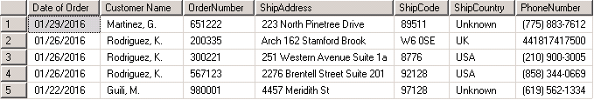



**Question 3**

SELECT convert(varchar(10), tblOrder.OrderDate, 101) as 'Date of Order',

concat(tblCustomer.LastName, ', ', left(tblCustomer.FirstName, 1), '.') as 'CustomerName',

tblOrder.OrderID as 'OrderNumber',

CASE

WHEN tblOrder.ShipAddress is not NULL

THEN tblOrder.ShipAddress

WHEN tblOrder.ShipAddress is NULL

THEN tblCustomer.Address

END ShipAddress,

CASE

WHEN tblOrder.ShipZip is not NULL

THEN tblOrder.ShipZip

WHEN tblOrder.ShipZip is NULL

THEN tblCustomer.Zip

END ShipCode,

CASE

WHEN tblOrder.ShipCountry is not NULL

THEN tblOrder.Shipcountry

WHEN (tblOrder.ShipCountry is NULL)

THEN 'Unknown'

END ShipCountry,

CASE

WHEN tblOrder.ShipCountry is NULL

THEN

'(' + substring(tblCustomer.Phone, 1, 3) + ') ' +

substring(tblCustomer.Phone, 4, 3) + '-' +

substring(tblCustomer.Phone, 7, 4)

WHEN tblOrder.ShipCountry = 'USA'

THEN

'(' + substring(tblOrder.ShipPhone, 1, 3) + ') ' +

substring(tblOrder.ShipPhone, 4, 3) + '-' +

substring(tblOrder.ShipPhone, 7, 4)

WHEN tblOrder.ShipCountry is not NULL

THEN tblOrder.ShipPhone

END PhoneNumber,

tblOrderLine.ItemID as 'ItemID',

tblOrderLine.Quantity as 'Quantity',

tblOrderLine.Price as 'Price',

tblOrderLine.Price * tblOrderLine.Quantity as 'ExtendedPrice'

FROM tblOrder

LEFT OUTER JOIN tblCustomer

ON tblOrder.CustomerID = tblCustomer.CustomerID

LEFT OUTER JOIN tblOrderLine

ON tblOrder.OrderID = tblOrderLine.OrderID

WHERE OrderDate BETWEEN ( '01/01/' + cast(year(getdate()) as varchar(4)))

AND ( '01/31/' + cast(year(getdate()) as varchar(4)))

ORDER BY OrderDate desc;

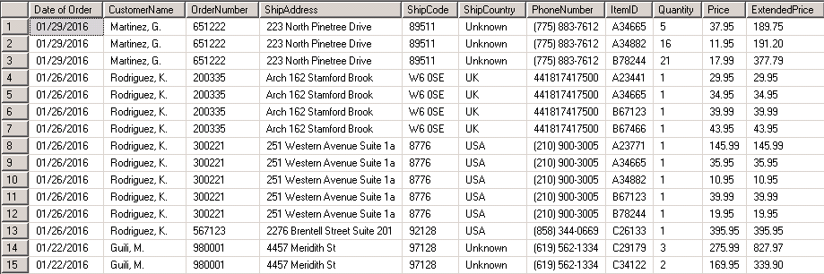



**Question 4**

SELECT convert(varchar(10), tblOrder.OrderDate, 101) as 'Date of Order',

concat(tblCustomer.LastName, ', ', left(tblCustomer.FirstName, 1), '.') as 'CustomerName',

tblOrder.OrderID as 'OrderNumber',

CASE

WHEN tblOrder.ShipAddress is not NULL

THEN tblOrder.ShipAddress

WHEN tblOrder.ShipAddress is NULL

THEN tblCustomer.CustomerAddress

END ShipAddress,

CASE

WHEN tblOrder.ShipZip is not NULL

THEN tblOrder.ShipZip

WHEN tblOrder.ShipZip is NULL

THEN tblCustomer.Zip

END ShipCode,

CASE

WHEN tblOrder.ShipCountry is not NULL

THEN tblOrder.Shipcountry

WHEN (tblOrder.ShipCountry is NULL)

THEN 'Unknown'

END ShipCountry,

CASE

WHEN tblOrder.ShipCountry is NULL

THEN

'(' + substring(tblCustomer.Phone, 1, 3) + ') ' +

substring(tblCustomer.Phone, 4, 3) + '-' +

substring(tblCustomer.Phone, 7, 4)

WHEN tblOrder.ShipCountry = 'USA'

THEN

'(' + substring(tblOrder.ShipPhone, 1, 3) + ') ' +

substring(tblOrder.ShipPhone, 4, 3) + '-' +

substring(tblOrder.ShipPhone, 7, 4)

WHEN tblOrder.ShipCountry is not NULL

THEN tblOrder.ShipPhone

END PhoneNumber,

tblOrderLine.ItemID as 'ItemID',

tblItem.Description as 'Description',

tblItemType.CategoryDescripition as 'CategoryDescription',

tblOrderLine.Quantity as 'Quantity',

tblOrderLine.Price as 'Price',

tblOrderLine.Price * tblOrderLine.Quantity as 'ExtendedPrice'

FROM tblOrder

LEFT OUTER JOIN tblCustomer

ON tblOrder.CustomerID = tblCustomer.CustomerID

LEFT OUTER JOIN tblOrderLine

ON tblOrder.OrderID = tblOrderLine.OrderID

LEFT OUTER JOIN tblItem

ON tblOrderLine.ItemID = tblItem.ItemID

LEFT OUTER JOIN tblItemType

ON tblItem.TypeID = tblItemType.TypeID

WHERE OrderDate BETWEEN ( '01/01/' + cast(year(getdate()) as varchar(4)))

AND ( '01/31/' + cast(year(getdate()) as varchar(4)))

ORDER BY OrderDate desc;

**-TABLE ON NEXT PAGE-**

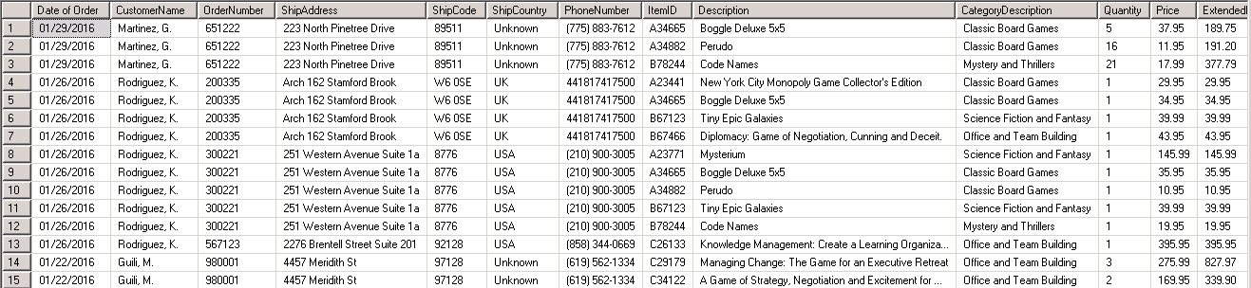



**Question 5**

SELECT convert(varchar, tblOrder.OrderDate, 101) as 'OrderDate',

tblOrder.OrderID as 'OrderNumber',

tblCustomer.LastName + ', ' + substring(tblCustomer.FirstName,1,1) + '.' as 'CustomerName',

CASE

WHEN tblOrder.ShipAddress IS NULL

THEN tblCustomer.Address

ELSE tblOrder.ShipAddress

END 'ShippingAddress',

CASE

WHEN tblOrder.ShipZip IS NULL

THEN tblCustomer.Zip

ELSE tblOrder.ShipZip

END 'ShippingCode',

CASE

WHEN tblOrder.ShipCountry IS NULL

THEN 'Unknown'

ELSE tblOrder.ShipCountry

END 'ShippingCountry',

CASE

WHEN tblOrder.ShipCountry <> 'USA'

THEN tblOrder.ShipPhone

WHEN tblOrder.ShipPhone IS NULL

THEN '(' + substring(tblCustomer.Phone,1,3) + ') ' + substring(tblCustomer.Phone,4,3)

+'-' + substring(tblCustomer.Phone,7,4)

ELSE '(' + substring(tblOrder.ShipPhone,1,3) + ') ' + substring(tblOrder.ShipPhone,4,3)

+'-' + substring(tblOrder.ShipPhone,7,4)

END 'CustomerTelephone',

tblOrderLine.ItemID,

tblItem.Description as 'Description',

tblItemType.CategoryDescripition as 'CategoryDescription',

tblOrderLine.Quantity as 'Quantity',

tblOrderLine.Price as 'Price',

(tblOrderLine.Quantity * tblOrderLine.Price) as 'ExtendedPrice'

FROM tblOrder

INNER JOIN tblCustomer

ON tblOrder.CustomerID=tblCustomer.CustomerID

INNER JOIN tblOrderLine

ON tblOrder.OrderID=tblOrderLine.OrderID

INNER JOIN tblItem

ON tblOrderLine.ItemID=tblItem.ItemID

INNER JOIN tblItemType

ON tblItem.TypeID=tblItemType.TypeID

WHERE datediff(month, tblOrder.OrderDate, getdate()) = 2

ORDER BY tblOrder.OrderDate decs;

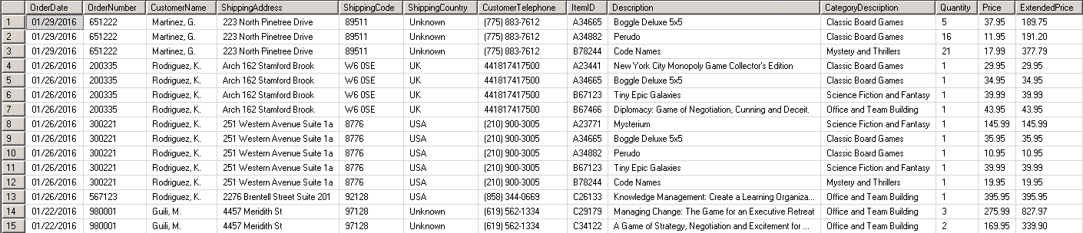



**Question 6**

SELECT OL.ItemID 'Item ID',

Item.Description 'Item Description',

SUM(OL.Quantity) 'Total Qty Sold',

COUNT(OL.OrderID) 'Count Of Order Lines',

MIN(OL.Price) 'Minimum Price',

MAX(OL.Price) 'Maximum Price',

AVG(OL.Price) 'Average Price'

FROM tblOrderLine OL

INNER JOIN tblItem Item

ON OL.ItemID = Item.ItemID

GROUP BY OL.ItemID,

Item.Description

ORDER BY OL.ItemID

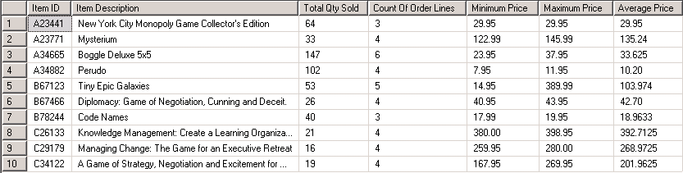



**Question 7**

SELECT ITEM.ItemID 'ItemID',

ITEM.Description 'ItemDescription',

ISNULL(SUM(OL.Quantity), 0) 'TotalQtySold',

COUNT(OL.OrderID) 'CountOfOrderLines',

ISNULL(MIN(OL.Price), 0) 'MinimumPrice',

ISNULL(MAX(OL.Price), 0) 'MaximumPrice',

ISNULL(AVG(OL.Price), 0) 'AveragePrice'

FROM tblItem ITEM

LEFT OUTER JOIN tblOrderLine OL

ON ITEM.ItemID = OL.ItemID

GROUP BY ITEM.ItemID,

ITEM.Description

ORDER BY ITEM.ItemID

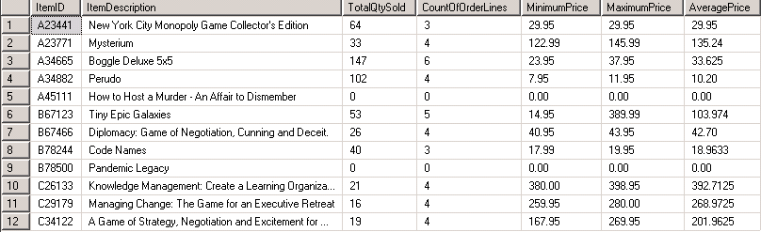



**Question 8**

SELECT ITEM.ItemID 'ItemID',

ITEM.Description 'Description',

ISNULL (Convert(VarChar,ICH.LastCostDate, 107), 'No Date Recorded') 'Last Cost Date',

ISNULL (Convert(VarChar,ICH.LastCost, 107),'0.00') 'Last Cost Paid'

FROM tblItem ITEM

LEFT OUTER JOIN tblItemCostHistory ICH

ON ITEM.ItemID = ICH.ItemID

GROUP BY ITEM.ItemID,

ITEM.Description,

ICH.LastCostDate,

ICH.LastCost

ORDER BY ITEM.ItemID ASC,

ICH.LastCostDate DESC

**-TABLE ON NEXT PAGE-**

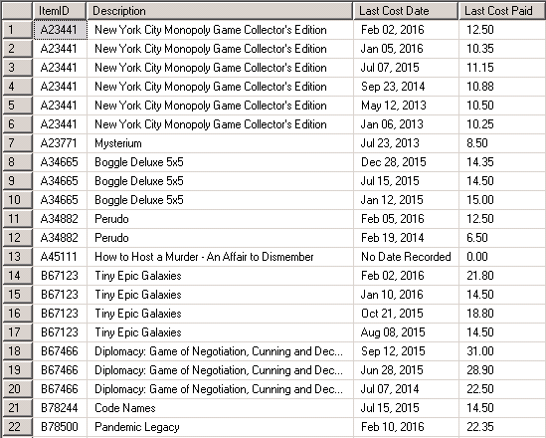



**Question 9**

SELECT ITEM.ItemID 'ItemID',

ITEM.Description 'Description',

ISNULL(Convert(VarChar,ICH.LastCostDate, 107), 'No Date') 'Last Cost Date',

ISNULL (Convert(VarChar,ICH.LastCost, 107),'0.00') 'Last Cost Paid'

FROM tblItem ITEM

LEFT OUTER JOIN tblItemCostHistory ICH

ON ITEM.ItemID = ICH.ItemID

WHERE ICH.LastCostDate =

(Select MAX(LastCostDate)

From tblItemCostHistory ICH2

Where ICH2.ItemID = ITEM.ItemID)

OR ICH.LastCostDate IS NULL

ORDER BY ItemID ASC,

LastCostDate DESC;

**-TABLE ON NEXT PAGE-**

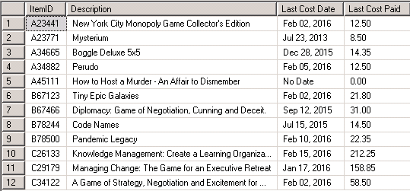



**Question 10**

SELECT ITEM.ItemID 'ItemID',

ITEM.Description 'Description',

ISNULL(CONVERT(VARCHAR, ICH.LastCostDate, 107), 'No Date') 'Last Cost Date',

(Select Count(ItemID)

From tblItemCostHistory ICH2

Where ICH2.ItemID = ITEM.ItemID) "Count of Purchases" ,

ISNULL (CONVERT(VARCHAR, ICH.LastCost, 107),'0.00') 'Last Cost Paid',

(Select ISNULL(ROUND(AVG(LastCost),2),0)

From tblItemCostHistory ICH3

Where ICH3.ItemID = ITEM.ItemID) "Average Last Cost"

FROM tblItem ITEM

LEFT OUTER JOIN tblItemCostHistory ICH

ON ITEM.ItemID = ICH.ItemID

WHERE ICH.LastCostDate =

(Select MAX(LastCostDate)

From tblItemCostHistory ICH4

Where ICH4.ItemID = ITEM.ItemID)

OR ICH.LastCostDate IS NULL

ORDER BY ItemID ASC,

LastCostDate DESC

**-TABLE ON NEXT PAGE-**

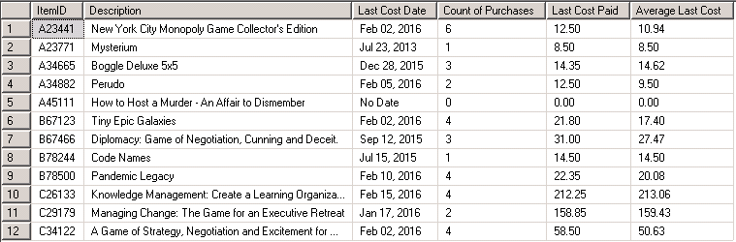



**Question 11**

SELECT line.OrderID,

line.ItemID,

line.Price,

line.Quantity,

ISNULL(SUM(ship.QtyShipped), 0) AS TotalQuantityShipped,

line.Quantity - ISNULL(SUM(ship.QtyShipped), 0) AS LeftToShip

FROM tblOrderLine as line

LEFT OUTER JOIN tblShipLine as ship

ON line.OrderID = ship.OrderId AND

line.ItemID = ship.ItemID

GROUP BY line.OrderID,

line.ItemID,

line.Price,

line.Quantity;

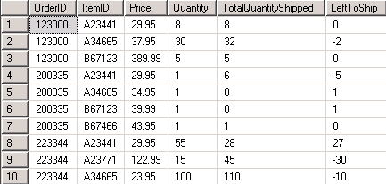



**Question 12**

SELECT line.OrderID,

cust.LastName + ', ' + cust.FirstName,

line.ItemID,

line.Price,

line.Quantity,

ISNULL(SUM(ship.QtyShipped), 0) AS TotalQuantityShipped,

line.Quantity - ISNULL(SUM(ship.QtyShipped), 0) AS LeftToShip

FROM tblOrderLine AS line

LEFT OUTER JOIN tblShipLine AS ship

ON line.OrderID = ship.OrderId AND

line.ItemID = ship.ItemID

LEFT OUTER JOIN tblOrder AS ord

ON line.OrderID = ord.OrderID

LEFT OUTER JOIN tblCustomer AS cust

ON ord.CustomerID = cust.CustomerID

GROUP BY line.OrderID,

cust.LastName,

cust.FirstName,

line.ItemID,

line.Price,

line.Quantity;

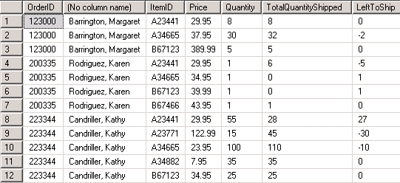



**Question 13**

SELECT line.OrderID,

cust.LastName + ', ' + cust.FirstName,

line.ItemID,

item.Description,

type.CategoryDescripition,

item.ListPrice,

line.Price,

line.Quantity,

ISNULL(SUM(ship.QtyShipped), 0) AS TotalQuantityShipped,

line.Quantity - ISNULL(SUM(ship.QtyShipped), 0) AS LeftToShip

FROM tblOrderLine AS line

LEFT OUTER JOIN tblShipLine AS ship

ON line.OrderID = ship.OrderId AND

line.ItemID = ship.ItemID

LEFT OUTER JOIN tblOrder AS ord

ON line.OrderID = ord.OrderID

LEFT OUTER JOIN tblCustomer AS cust

ON ord.CustomerID = cust.CustomerID

LEFT OUTER JOIN tblItem AS item

ON line.ItemID = item.ItemID

LEFT OUTER JOIN tblItemType AS type

ON item.TypeID = type.TypeID

GROUP BY line.OrderID,

cust.LastName,

cust.FirstName,

line.ItemID,

item.Description,

type.CategoryDescripition,

item.ListPrice,

line.Price,

line.Quantity;

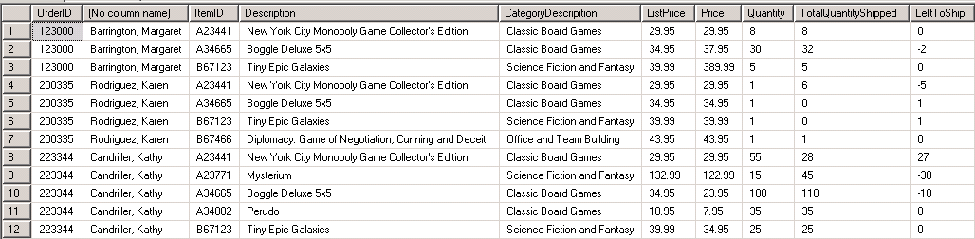



**Question 14**

SELECT line.OrderID,

cust.LastName + ', ' + cust.FirstName,

line.ItemID,

item.Description,

type.CategoryDescripition,

item.ListPrice,

line.Price,

line.Quantity,

ISNULL(SUM(ship.QtyShipped), 0) AS TotalQuantityShipped,

line.Quantity - ISNULL(SUM(ship.QtyShipped), 0) AS LeftToShip

FROM tblOrderLine AS line

LEFT OUTER JOIN tblShipLine AS ship

ON line.OrderID = ship.OrderId AND

line.ItemID = ship.ItemID

LEFT OUTER JOIN tblOrder AS ord

ON line.OrderID = ord.OrderID

LEFT OUTER JOIN tblCustomer AS cust

ON ord.CustomerID = cust.CustomerID

LEFT OUTER JOIN tblItem AS item

ON line.ItemID = item.ItemID

LEFT OUTER JOIN tblItemType AS type

ON item.TypeID = type.TypeID

GROUP BY line.OrderID,

cust.LastName,

cust.FirstName,

line.ItemID,

item.Description,

type.CategoryDescripition,

item.ListPrice,

line.Price,

line.Quantity

HAVING line.Quantity - ISNULL(SUM(ship.QtyShipped), 0) < 0

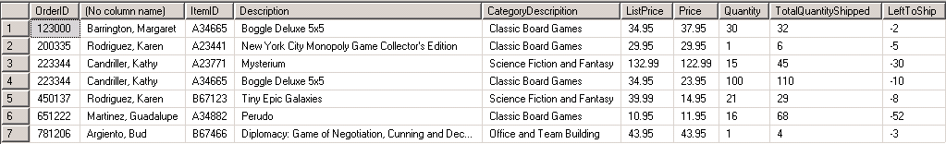



**Question 15**

SELECT cust.LastName + ', ' + cust.FirstName CustomerName,

line.OrderID,

line.ItemID,

item.Description

FROM tblOrderLine AS line

LEFT OUTER JOIN tblItem AS item

ON line.itemID = item.itemID

LEFT OUTER JOIN tblOrder AS ord

ON line.OrderID = ord.OrderID

LEFT OUTER JOIN tblCustomer AS cust

ON ord.CustomerID = cust.CustomerID

LEFT OUTER JOIN tblShipLine AS ship

ON line.OrderID = ship.OrderID AND

line.ItemID = ship.ItemID

WHERE ship.MethodShipped = 'FedEx'



